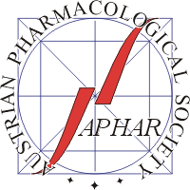
Student Travel Grant Application
30th Scientific Symposium of the
Austrian Pharmacological Society (APHAR)
Linz, 28 − 30 September 2026
The Austrian Pharmacological Society (APHAR) offers a limited number of travel grants for students who are working in the field of pharmacology and who are presenting author of an abstract at the 30th Scientific Symposium of APHAR, Linz, Austria. The grants will be awarded to students affiliated to pharmacological or related departments (except Linz). The grant sum is 200 Euro.
Students who want to apply for these grants should fill in this application form. The form must also be signed by the project director or head of department.
Name of applicant:
Institution:
E-Mail:
Title of Abstract:
Project director:
Date: ______________
___________________________________ ___________________________________
Applicant’s signature Signature of project director
or Head of department
All applications should be sent as scanned pdf file (alternatively as fax) to the meeting organisers (see at bottom). Applications are only considered complete when the accompanying abstract has been received by the organisers. Please note that the applicant has to register as participant (student participation fee) for the meeting.
All applicants will be informed prior to the symposium whether their application has been successful. Scholarship holders will receive the grant sum at the end of the meeting upon presenting the attendance certificate to the APHAR office. The certificate will be issued at the registration desk.
Please send as scanned PDF file to
thomas.griesbacher@medunigraz.at

