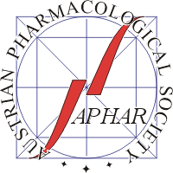

www.aphar.at
Confirmation of Student Status
to be presented at the registration desk of the
30th Scientific Symposium of the Austrian Pharmacological Society (APHAR)
Linz, 28 − 30 September 2026
for entitlement to payment of a
reduced registration fee

This is to confirm that
First name | Last name
is a student at the
Institution
Name of the project:

Note that payment of the student registration fee must be made online prior to the meeting (see meeting website: https://www.aphar.at/2026)

Head of institution / PI:
Name:
Signature:
Date:

Please complete this form and present it at the registration desk of the meeting.

