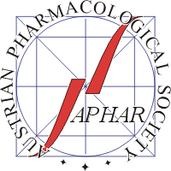
Student Travel Grant Application
27th Scientific Symposium of the Austrian Pharmacological Society (APHAR)
Vienna, 29 – 30 September 2023
The Austrian Pharmacological Society (APHAR) offers a limited number of travel grants for students who are working in the field of pharmacology and who are presenting author of an abstract at the 27th Scientific Symposium of APHAR, Vienna, Austria. The grants will be awarded to students affiliated to pharmacological or related departments (except Vienna). The grant sum is Euro 200.
Students who want to apply for these grants should fill in this application form. The form must also be signed by the project director or head of department.
All applications should be sent as scanned pdf file (alternatively as fax) to the meeting organisers (see at bottom). Applications are considered complete when the accompanying abstract has been received by the organisers.
All applicants will be informed prior to the symposium whether their application has been successful. Scholarship holders will receive the grant sum at the end of the meeting upon presenting the attendance certificate to the APHAR office. The certificate will be issued at the registration desk.
Name of applicant:
Institution:
E-Mail:
Title of Abstract:
Project director:
Date: ______________
___________________________________ ___________________________________
Applicant’s signature Signature of project director
or Head of department
Please send as scanned PDF file to
lehre-pharmakologie@medunigraz.at

