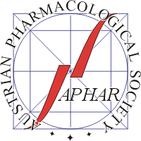

www.aphar.at
Confirmation of Student Status
to be presented at the registration desk of the
27th Scientific Symposium of the Austrian Pharmacological Society (APHAR)
Vienna, 29 – 30 September 2023
for entitlement to payment of a
reduced registration fee

This is to confirm that
First name | Last name
is a student at the
Institution

Head of institution:
Name:
Signature:
Date:

Please complete this form and present it at the registration desk of the meeting.

