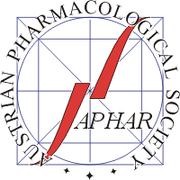

www.aphar.at
Confirmation of Student Status
to be presented at the registration desk of the
24th Scientific Symposium of the Austrian Pharmacological Society (APHAR)
Graz, 27–28 September 2018
for entitlement to payment of a
reduced registration fee

This is to confirm that
First name | Last name
is a student at the
Institution

Head of institution:
Name:
Signature:
Date:

Please complete this form and present it at the registration desk of the meeting.

